**Style Guide**

**Client**

My client is a non-profitable organization which focuses on stray cat rescue, medical issues, and adoption, etc. They want to get more exposure, so that they can attract more people to give attention to or adopt their cats, to get more people volunteer for them, etc. They think it will also be a great thing to let more people know their efforts by having a good website for people to browse.

**Style**

This series of webpages contains a lot of cat pictures, so it is bound to be cute. But at the same time, since it is about rescuing and saving stray cats, it should also be a serious thing. Thus, while the pics are in charge of cuteness, the fonts, formatting and colors are relatively formal. The designer hopes that the page can call out people’s sympathy and attention to stray cats. And also, it may give people an urge to adopt one or even more from the client!

**Platform**

The website will target traditional monitor resolutions of 1024X768 and greater.

**Semantic Design Guide**

**Index.html**

1. Header (logo+Navigation bar)



* In this webpage, header is composed by two parts: Logo and Navigation Bar. This part is mainly used for it’s navigating function.
* Div names: top; topleft; topright, navbar.
* Font Choice: Arial, Helvetica, sans-serif.
* Color Choice: #365b6d(The same font color of the logo)
* Image: max-width: 45% (original:317px)
* Layout Location: The whole part is at the top of the whole page, with logo block on the left side and navigation bar on the right side.

1. Main

2.1 Section 1 (#slogan)

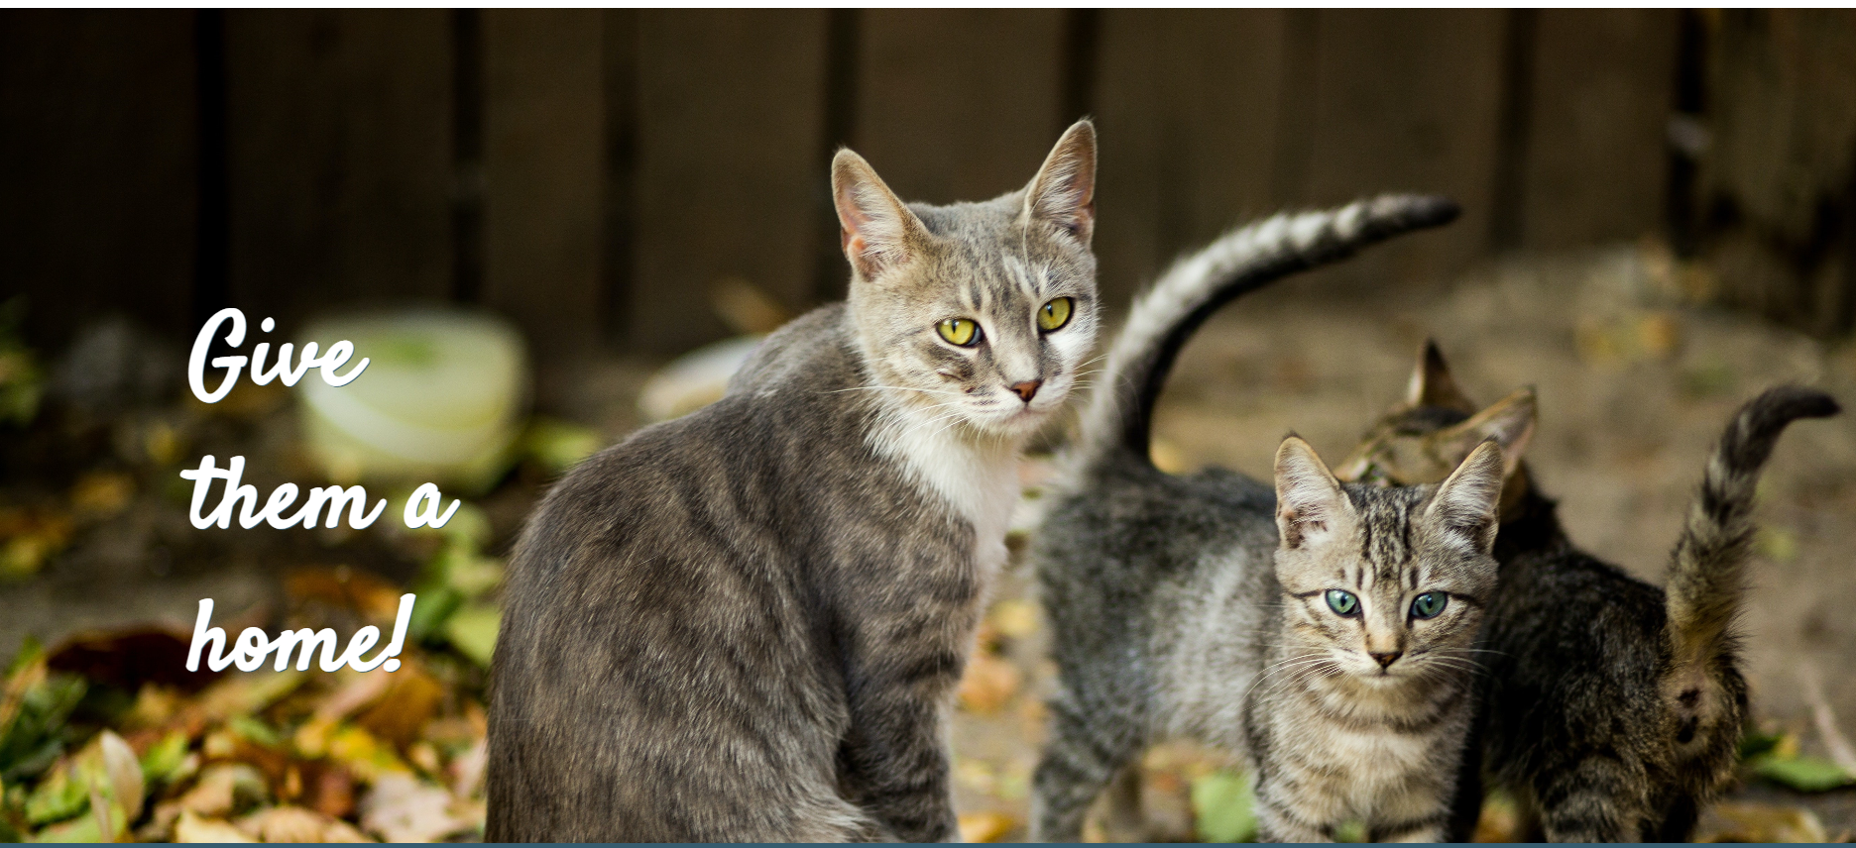

* This part is used to impress the viewers.
* Div names: #catfamily
* Font Choice: "Satisfy"
* Color Choice: White for font.
* Image: Background image; background-size:cover.
* Layout Location: The first section of the main part. The slogan is on the left bottom.

2.2 Section 2 (#aboutus)

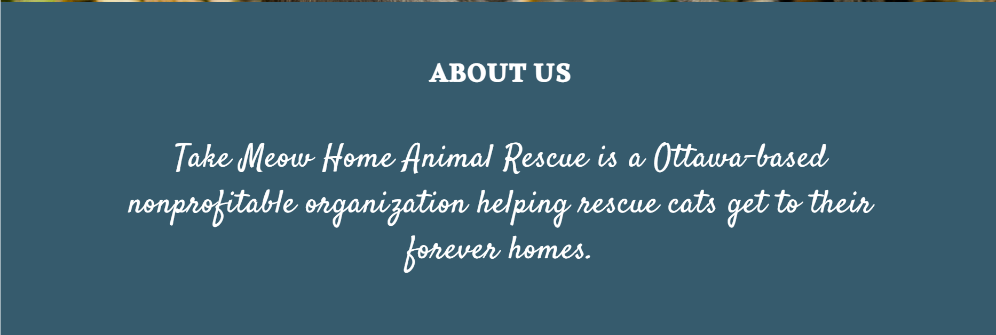

* This part is used to introduce the business.
* Div names: #about
* Font Choice: 'Alkalami' and "Satisfy"
* Color Choice: Background- #365b6d; fontcolor-white.
* Image: none
* Layout Location: Second section of the main part. All text are centered.

2.3 Section 3 (#help)

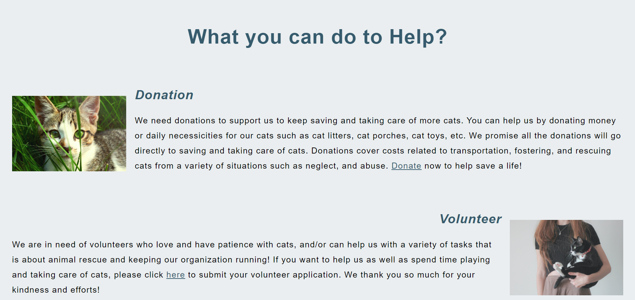

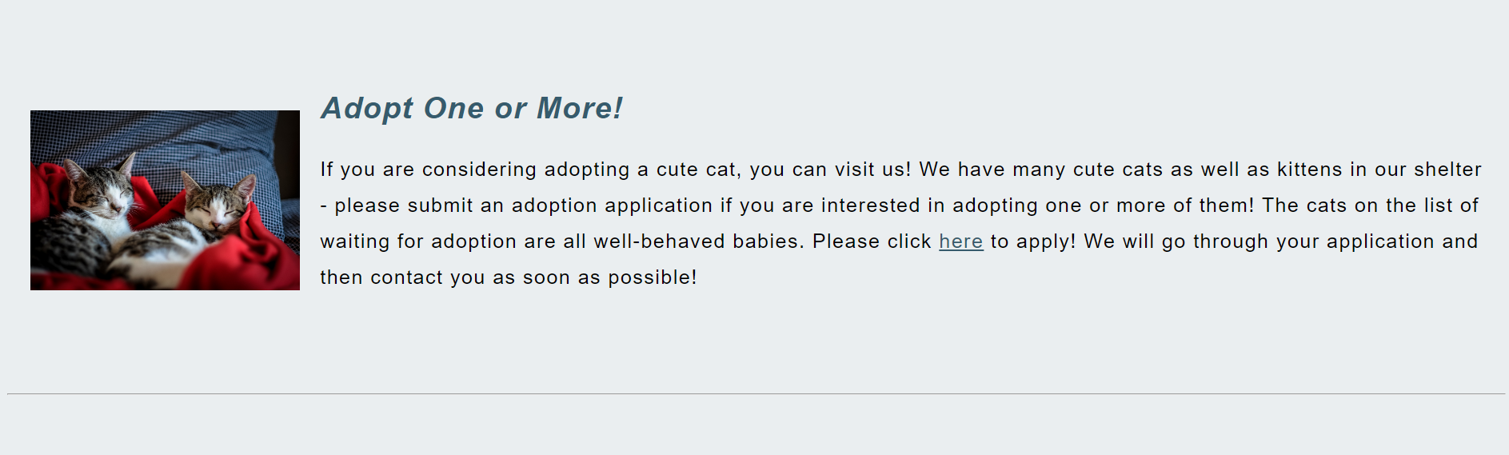

* This part is used to let the viewers be aware of possible ways to help this non-profitable organization.
* Div names: #help-title, #tips(includes #description1, #description2, #description3)
* Font Choice: Arial, Helvetica, sans-serif.
* Color Choice: #365b6d(for help title and h2),black(for paragraphs).
* Image: 3 images beside 3 paragraphs. Height is 180px. Width is not specified.
* Layout Location: The third section of the main part. The tile is centered. First and third picture are left floated, second one is right floated. All h2 font have italic style. H2 and paragraphs are aligned to the left side excepted the second h2.

2.4 Section 4 (#list)

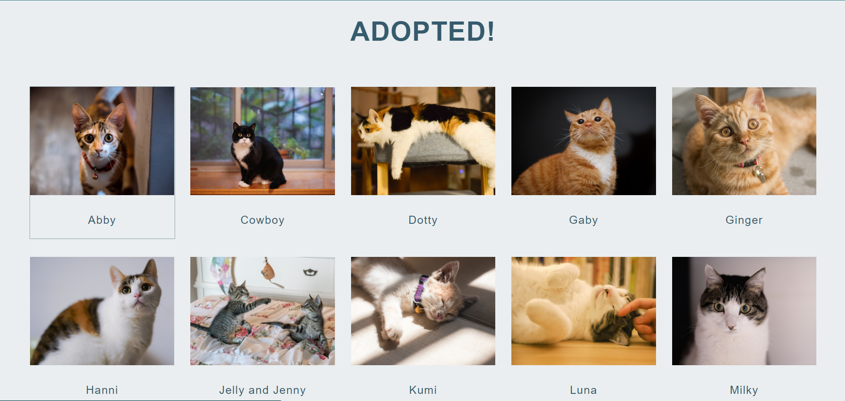

* This part is a gallery used to show adopted cats.
* Div names: #adopted, #gallerypic(same for 10 picture divs), #desc(same for 10 caption divs)
* Font Choice: Arial, Helvetica, sans-serif.
* Color Choice: Fontcolor-#365b6d.
* Image: 10 pictures in the same size, all with a width of 260px.
* Layout Location: The fourth part of the whole main part. Title is centered. The gallery is composed of 10 pics, with 5 pics in each line. And pic divs are inline-blocks, centered.

2.5 Section 5(#contactus)

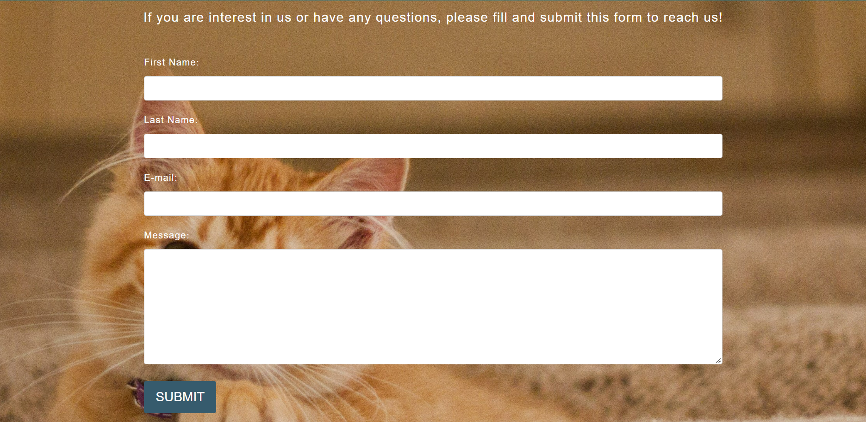

* This part is a form for users to leave her/his message.
* Div names: #contact, #contacttop, #contactbottom, #button
* Font Choice: Arial, Helvetica, sans-serif.
* Color Choice: Fontcolor-white; submit button: #365b6d(#8A9FAA when hover)
* Image: background image; background-size: cover.
* Layout Location: The 5th part of the whole main part. All elements are centered.

1. Footer



* This part is to show the address, email, telephone number and copyright of this organization.
* Div names: #address(for address part), #copyright.
* Font Choice: Arial, Helvetica, sans-serif.
* Color Choice: Fontcolor: white; background color: #365b6d.
* Image: none.
* Layout Location: All elements are centered.

**volunteer.html**

1. Header

Same as the header in index.html

1. Main
   1. Section1(#beavolunteer)

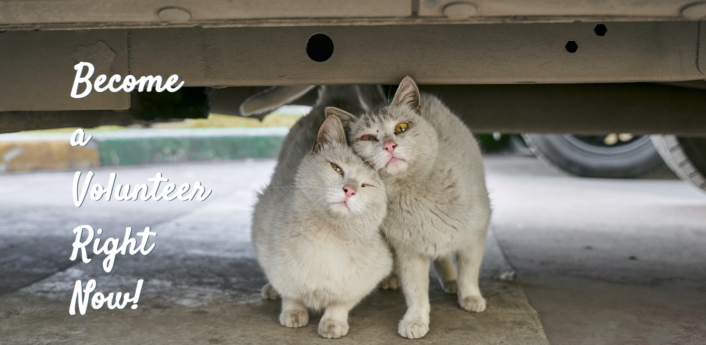

* This part is used to impress the viewers.
* Div names: #vol
* Font Choice: "Satisfy"
* Color Choice: White for font.
* Image: Background image; background-size: cover.
* Layout Location: The first section of the main part. The slogan is on the left bottom.

2.2 Section2(#volapply)

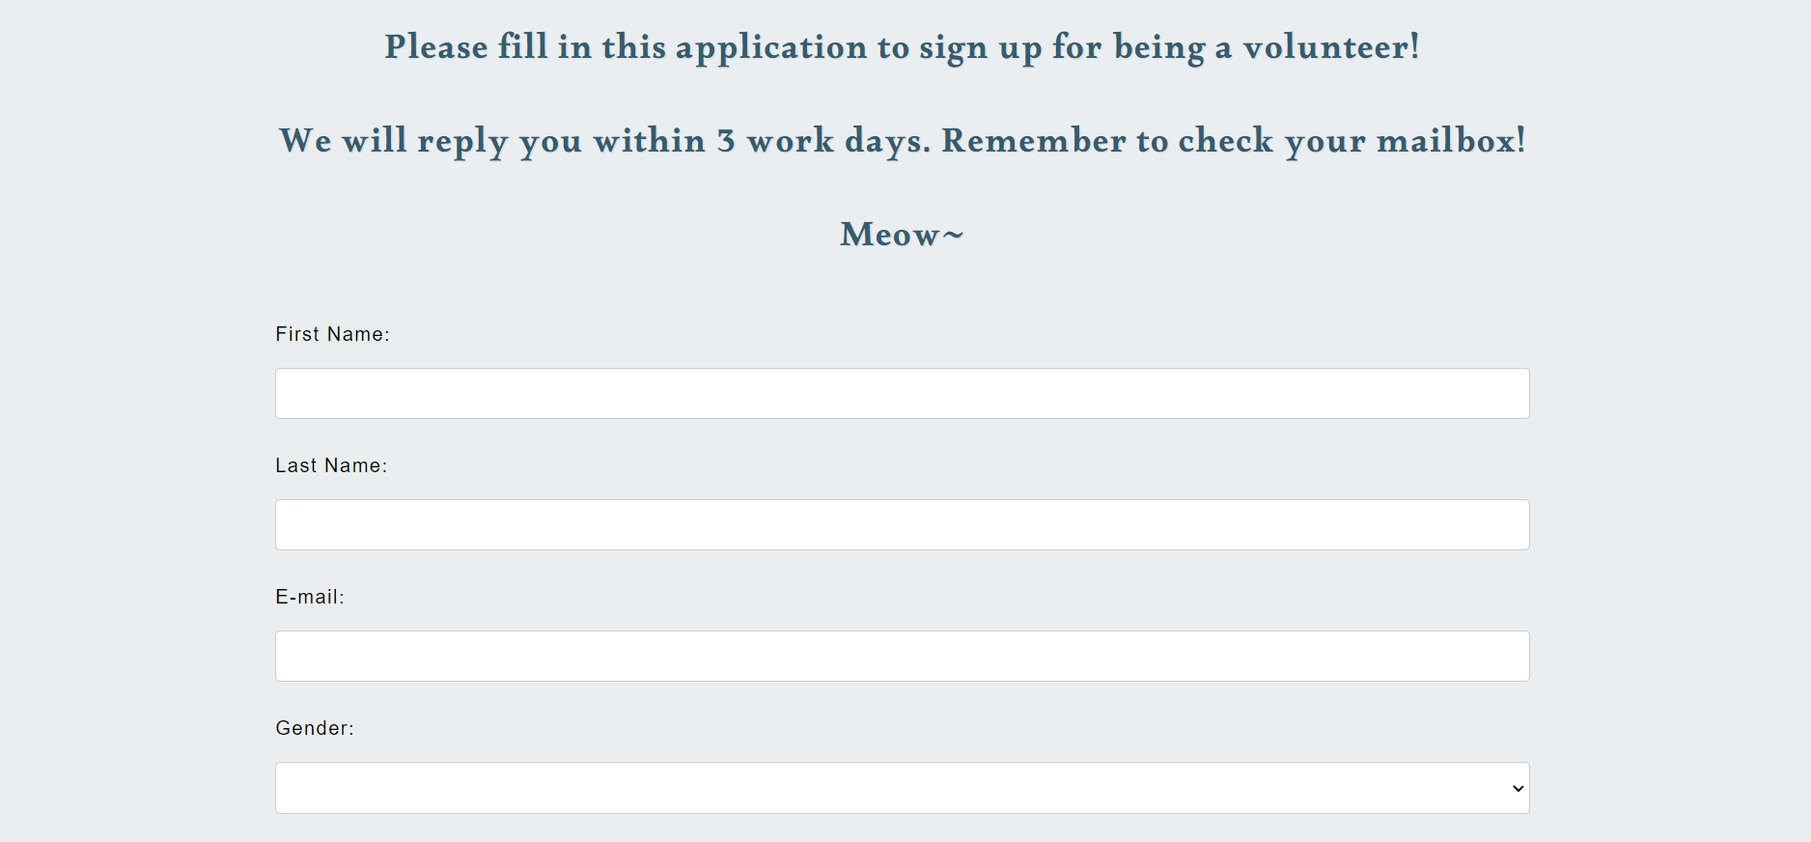

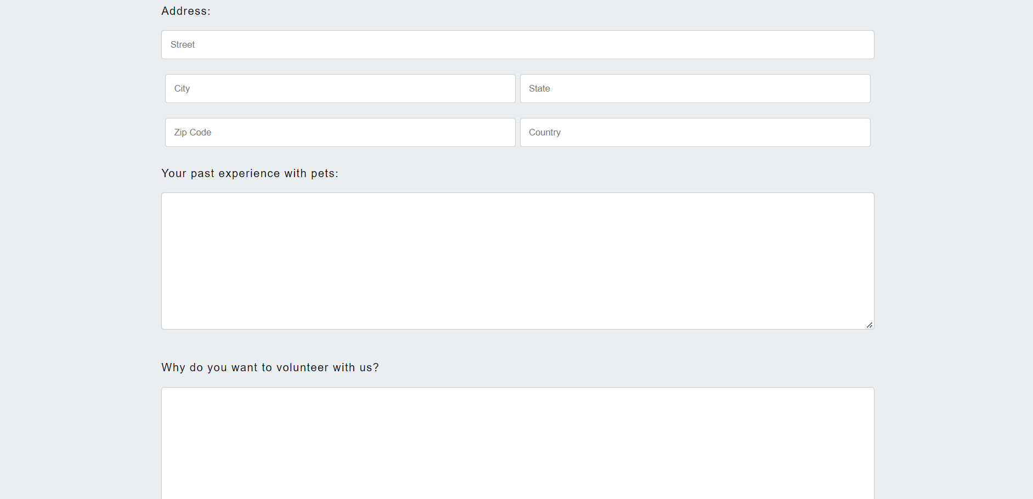

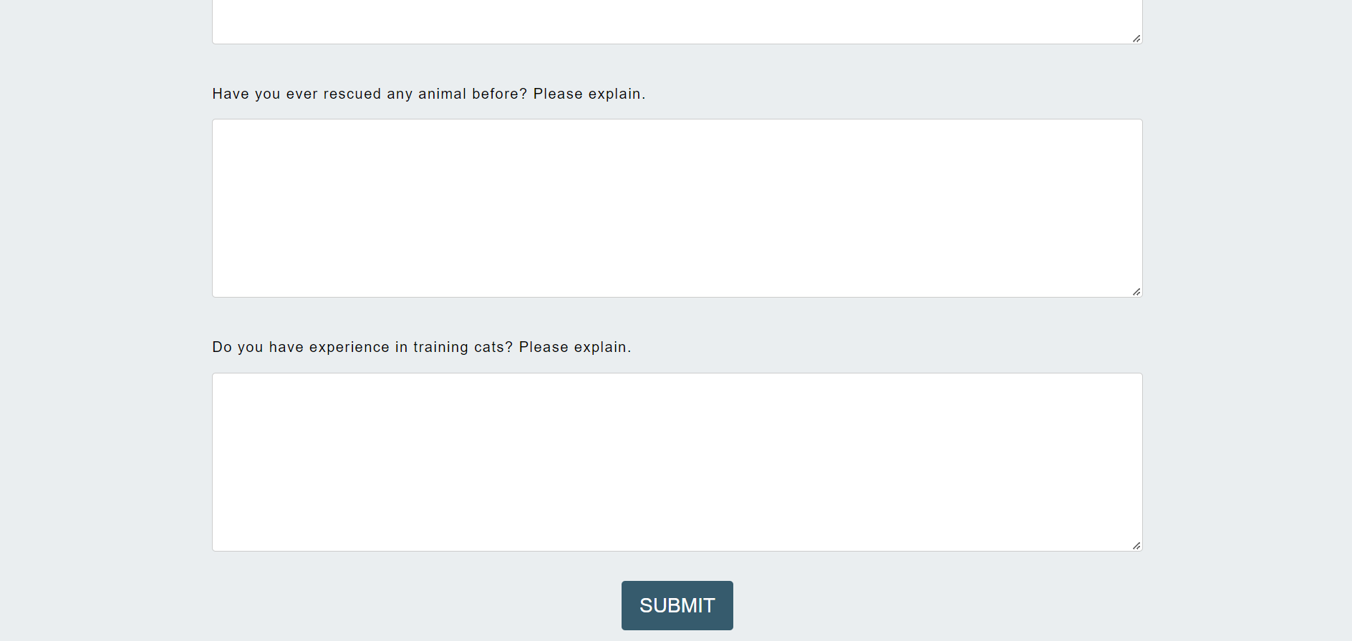

* This part is a form for possible volunteers to fill and apply for the position.
* Div names: #apply, #applytop, #applybottom, #where(for the address form part), #button
* Font Choice: Paragraphs before the whole form: 'Alkalami'; Form part: Arial, Helvetica, sans-serif.
* Color Choice: #365b6d for paragraphs before the whole form. White for font.
* Image: none.
* Layout Location: The second section of the main part. All elements are centered.

3. Footer

Same as the footer in index.html

**adopt.html**

1. Header

Same as the header in index.html

1. Main

2.1 Section1(#adopt2)

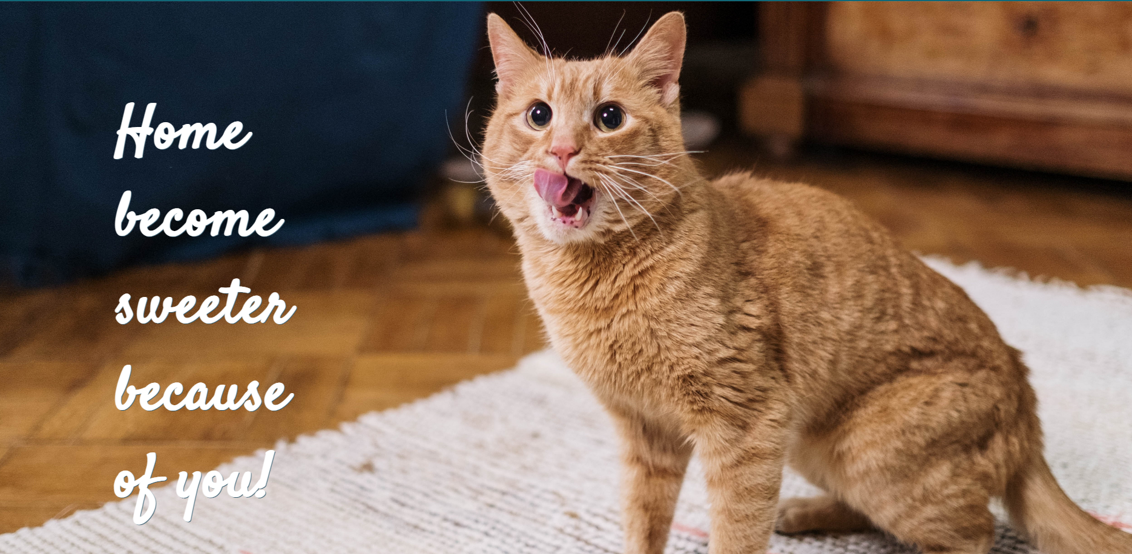

* This part is used to impress the viewers.
* Div names: #catfamily
* Font Choice: "Satisfy"
* Color Choice: White for font.
* Image: Background image; background-size: cover.
* Layout Location: The first section of the main part. The slogan is on the left bottom.

2.2 Section2 + 3 (#list)

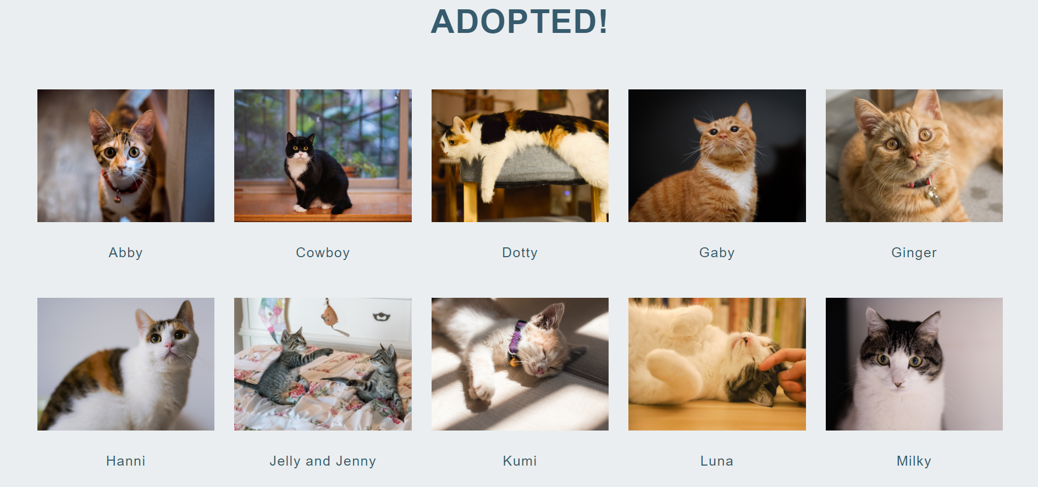

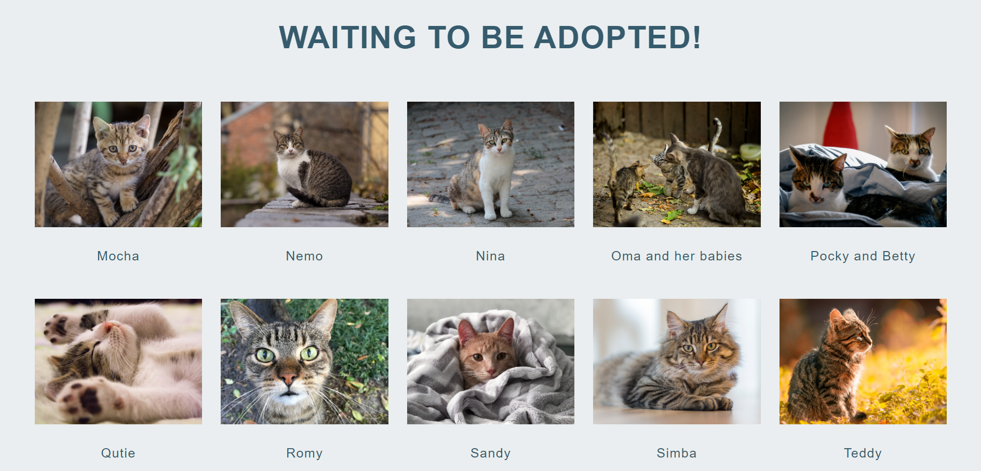



* This part is a gallery used to show adopted cats.
* Div names: #adopted, #gallerypic(same for 10 picture divs), #desc(same for 10 caption divs)
* Font Choice: Arial, Helvetica, sans-serif.
* Color Choice: Fontcolor-#365b6d.
* Image: 10 pictures in each section, in the same size, all with a width of 260px.
* Layout Location: The second and third part of the whole main part. Title is centered. Each of the gallery is composed of 10 pics, with 5 pics in each line. And pic divs are inline-blocks, centered.

3. Footer

Same as the footer in index.html

**donation.html**

1. Header

Same as the header in index.html

1. Main

2.1 Section1(#donating)

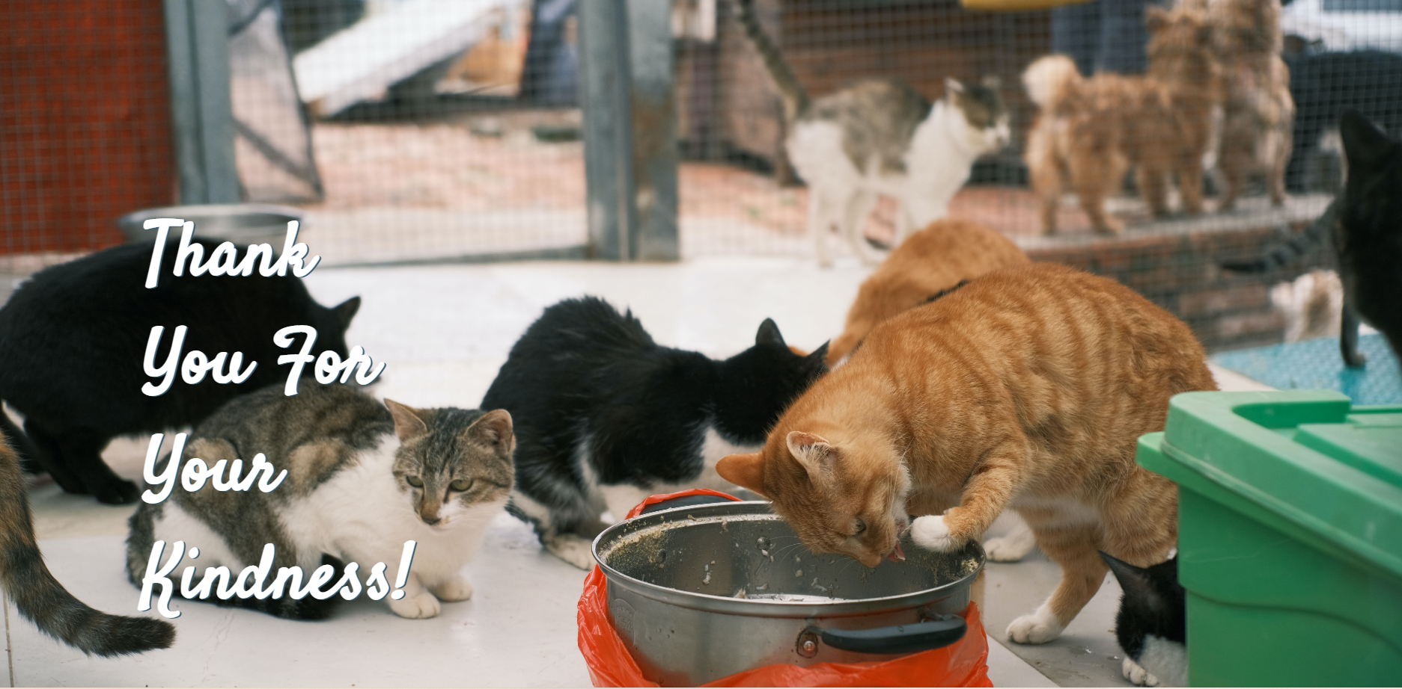

* This part is used to impress the viewers.
* Div names: #donate
* Font Choice: "Satisfy"
* Color Choice: White for font.
* Image: Background image; background-size: cover.
* Layout Location: The first section of the main part. The slogan is on the left bottom.

2.2 Section2(#yeardonate)

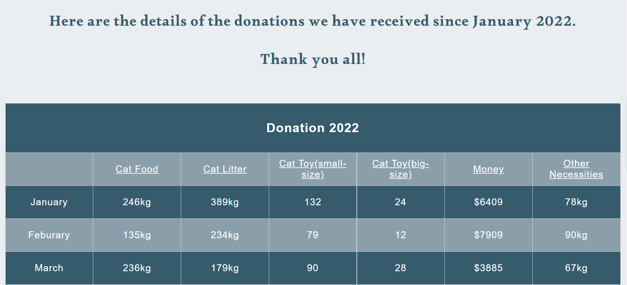

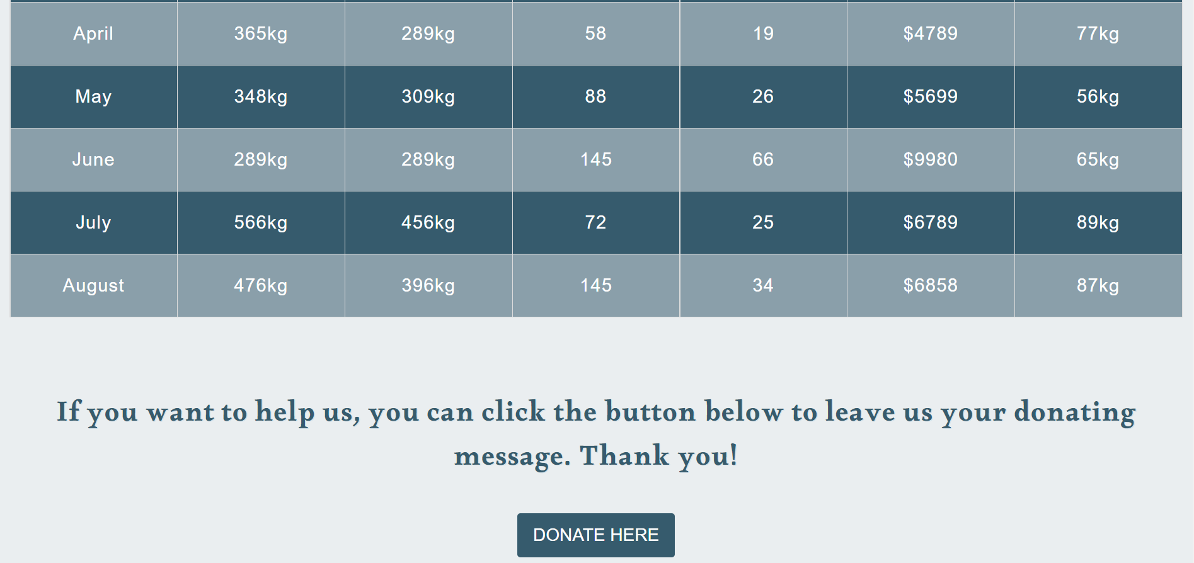

* This part is a form for possible volunteers to fill and apply for the position.
* Div names: #donation-description, #donation-table, #plzdonate
* Font Choice: Paragraphs before and after the table: 'Alkalami'; Table part: Arial, Helvetica, sans-serif.
* Color Choice: #365b6d for paragraphs before and after the whole form. White for other texts.
* Image: none.
* Layout Location: The second section of the main part. All elements are centered.

3. Footer

Same as the footer in index.html

**donation2.html**

1. Header

Same as the header in index.html

1. Main

2.1 Section1(#donating2)

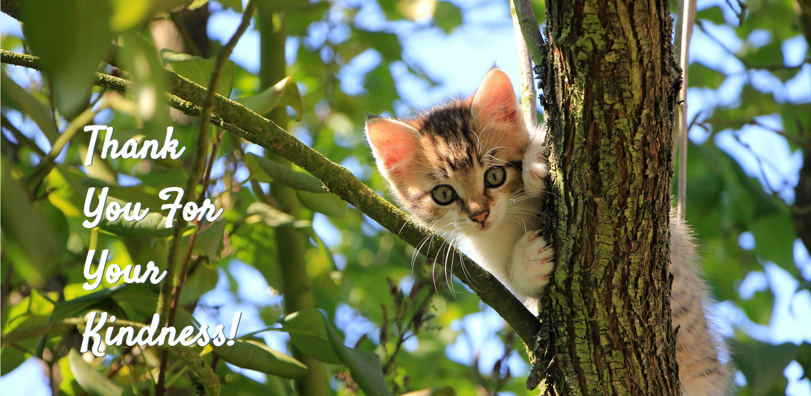

* This part is used to impress the viewers.
* Div names: #donate
* Font Choice: "Satisfy"
* Color Choice: White for font.
* Image: Background image; background-size: cover.
* Layout Location: The first section of the main part. The slogan is on the left bottom.

2.2 Section2(#donateinfo)

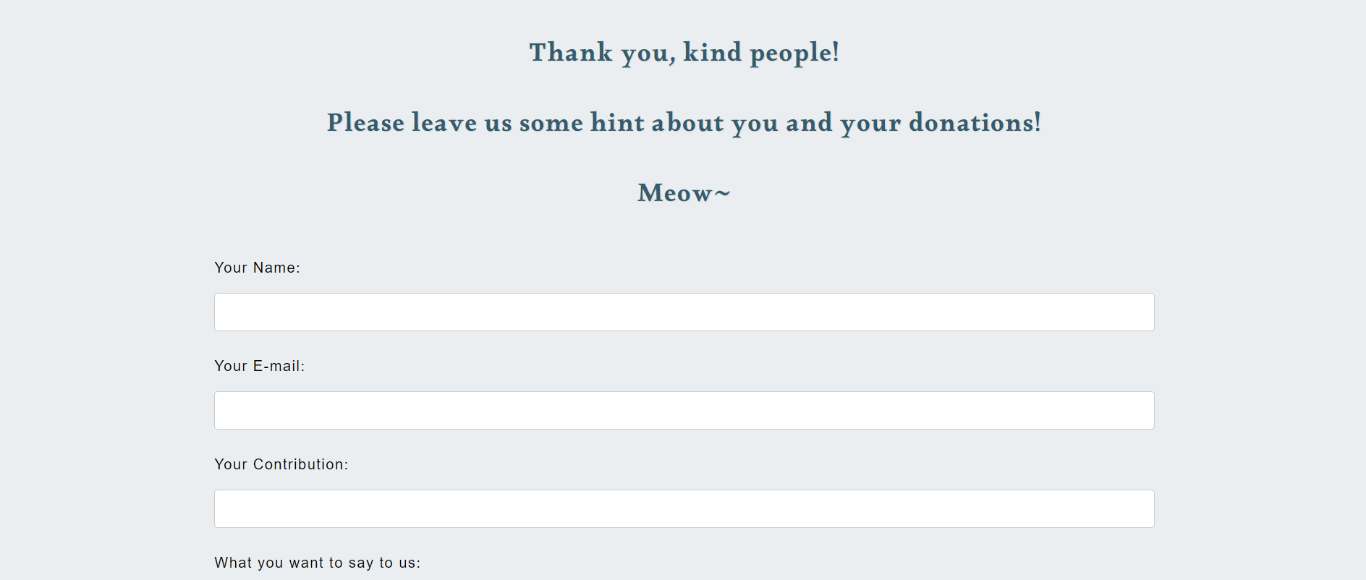

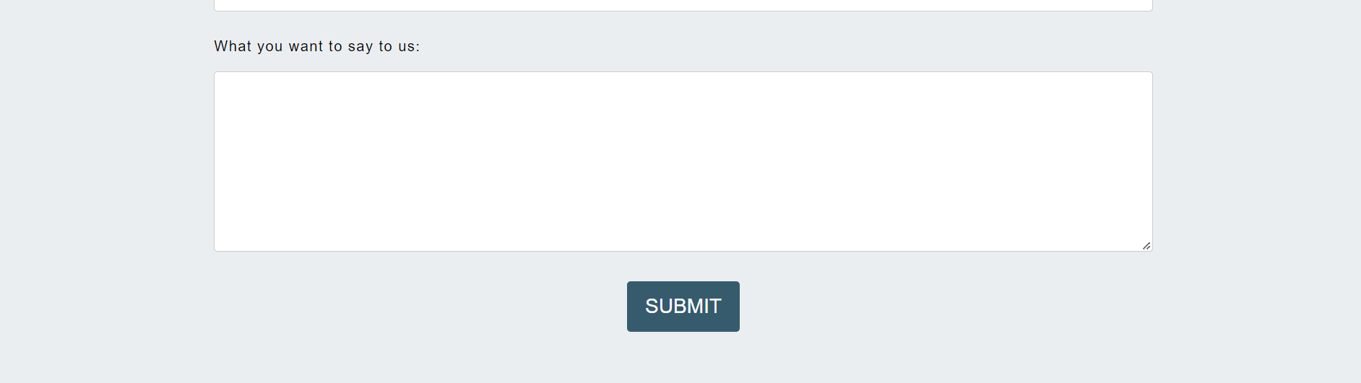

* This part is a form for possible donators to leave their message.
* Div names: #apply, #applytop, #applybottom, #button
* Font Choice: Paragraphs before the whole form: 'Alkalami'; Form part: Arial, Helvetica, sans-serif.
* Color Choice: #365b6d for paragraphs before the whole form. White for font.
* Image: none.
* Layout Location: The second section of the main part. All elements are centered.

3. Footer

Same as the footer in index.html

**adopt2.html**

1. Header

Same as the header in index.html

1. Main

2.1 Section1(#adopt)

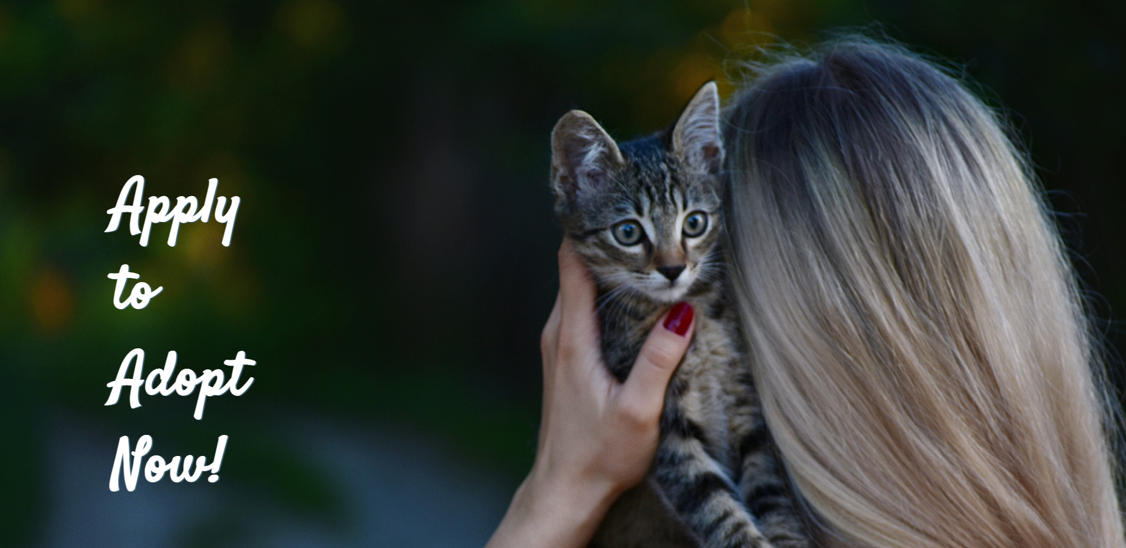

* This part is used to impress the viewers.
* Div names: #adoptapp
* Font Choice: "Satisfy"
* Color Choice: White for font.
* Image: Background image; background-size: cover.
* Layout Location: The first section of the main part. The slogan is on the left bottom.

2.2 Section2(#adoptapply)

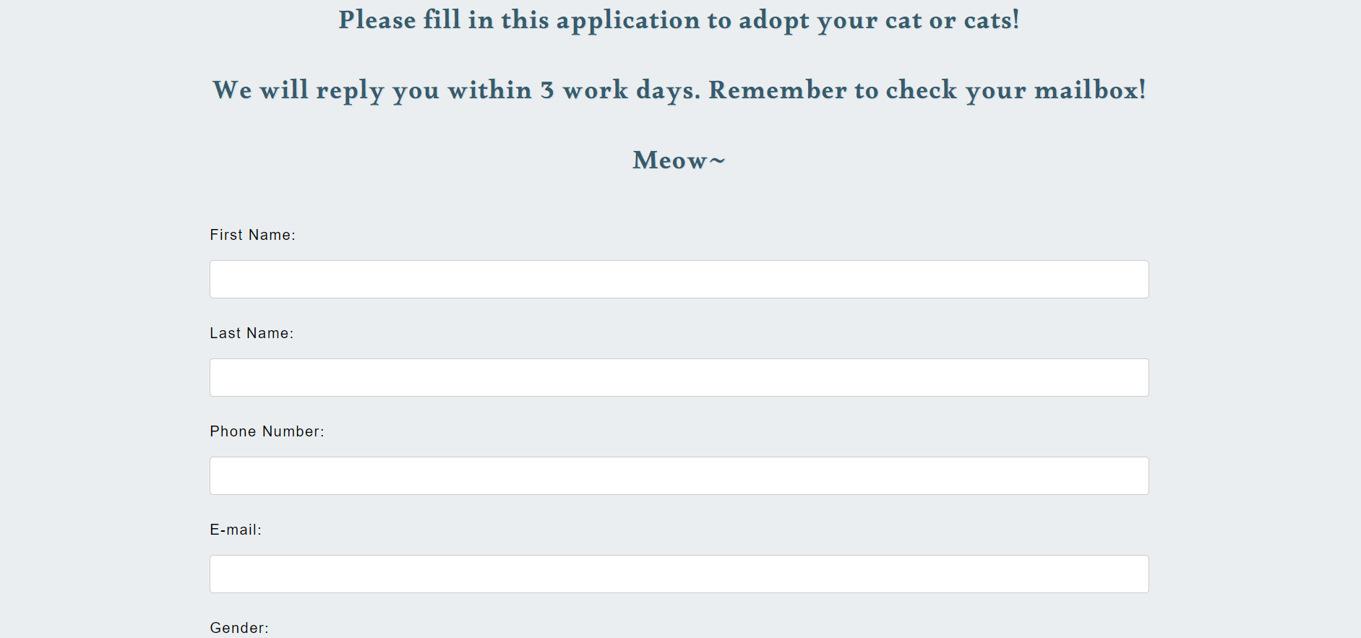

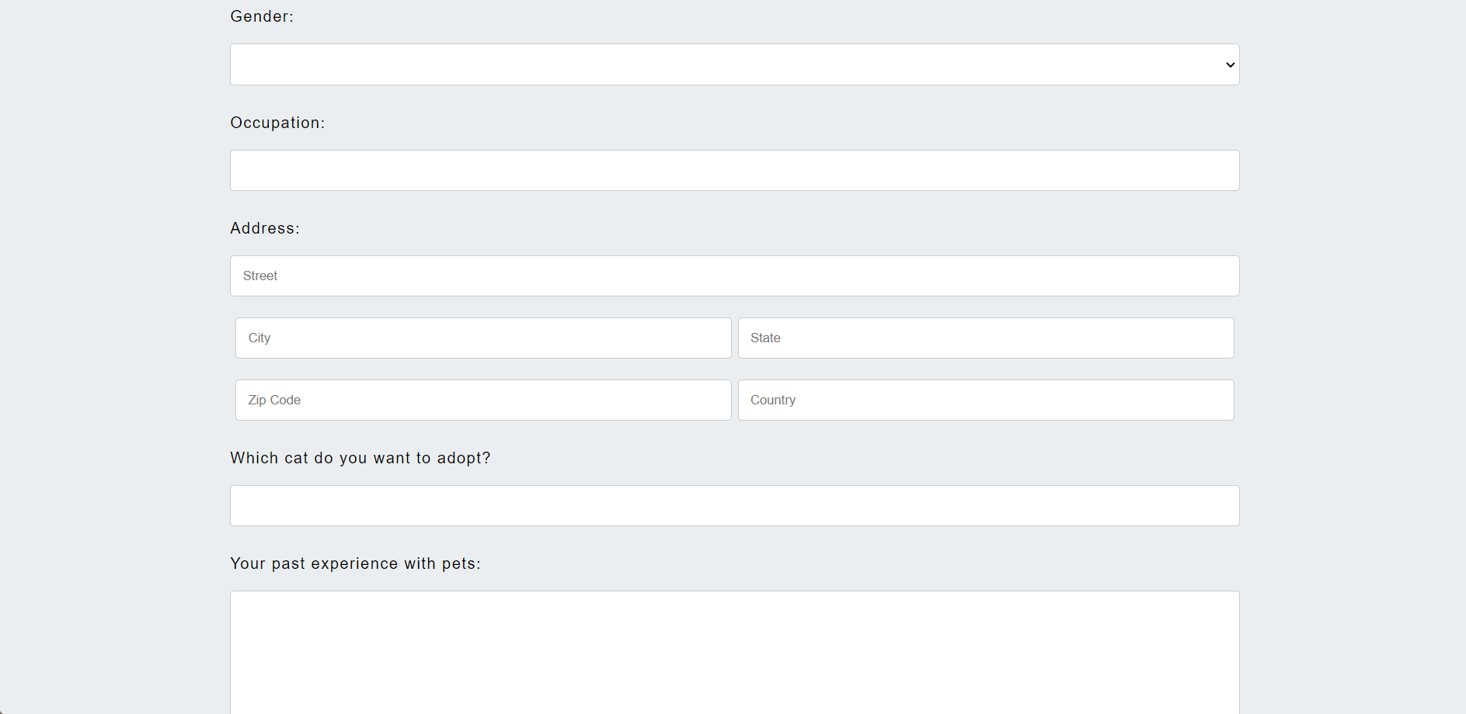

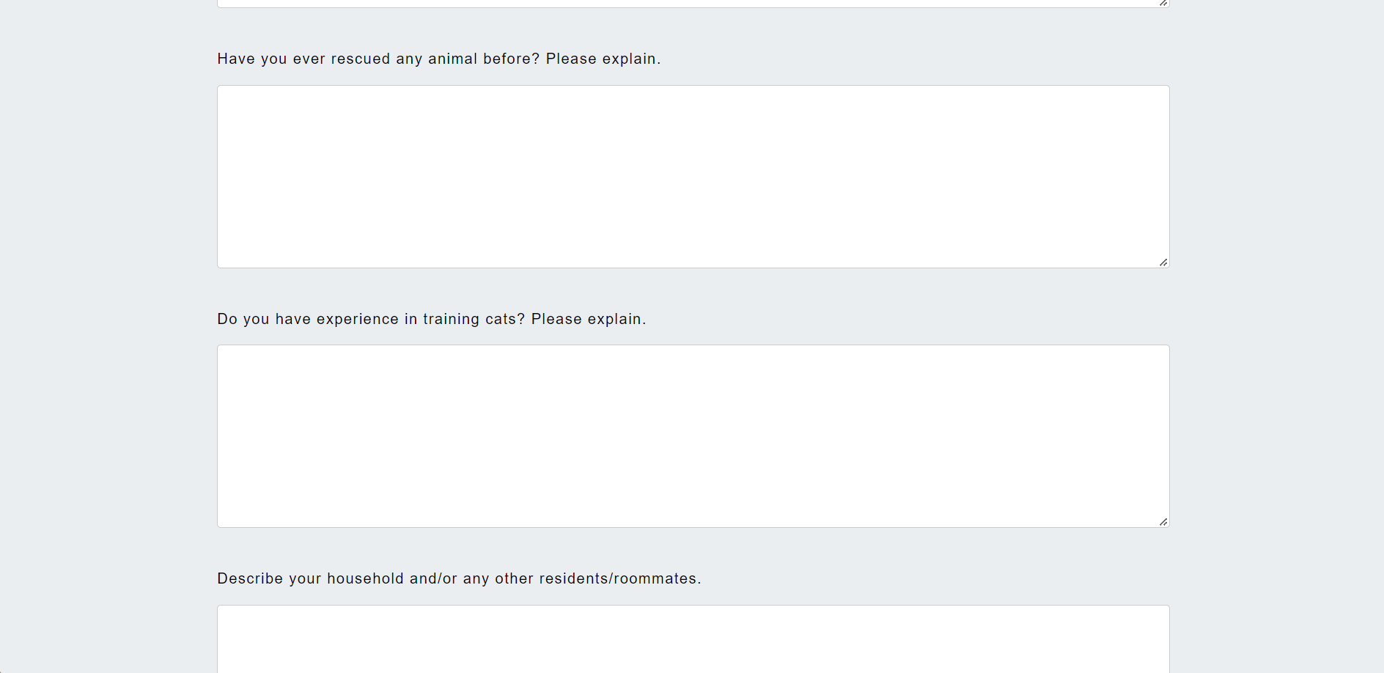

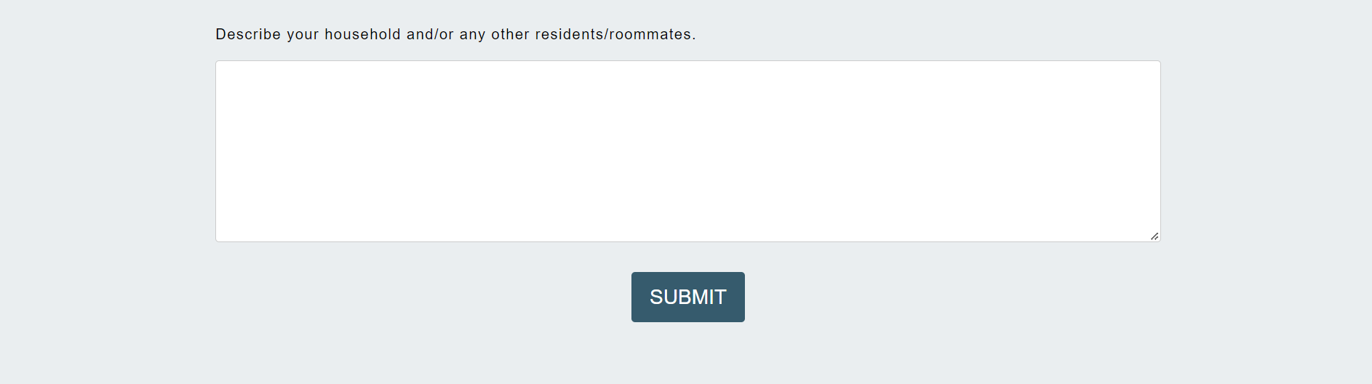

* This part is a form for possible donators to leave their message.
* Div names: #apply, #applytop, #applybottom, #where(for the address part), #button
* Font Choice: Paragraphs before the whole form: 'Alkalami'; Form part: Arial, Helvetica, sans-serif.
* Color Choice: #365b6d for paragraphs before the whole form. White for font.
* Image: none.
* Layout Location: The second section of the main part. All elements are centered.

3. Footer

Same as the footer in index.html

**\*The C.R.A.P in these pages**

1. Contrast: Using deep blue and light blue and white color, and when there’s a background picture whose color is deep, the light color font is used in this section.

2. Repetition: The color being mainly used are extracted from the logo picture. They are black, white, #97AAB3, #365B6D, #FFFFFF.

3. Alignment: The alignment for most parts is center. But several parts are left or right aligned, according to what kind of outcome is needed. The whole page has a margin of 8px, and there is 80px-100px margin between each section/and header or footer. which makes it look not crowded and properly formatted.

4. Proximity: Most parts are linked vertically as big blocks. But for some parts, such as the header, forms, and galleries, there are smaller divs which are mostly displayed as inline-blocks, and can fit the content when shrink the window size.

**Website Map**

To Donate

Adoption Application

Contact Us

Donation

Adoption(Info)

Volunteer

About Us

Home(Refresh)

Landing Page(index.html)